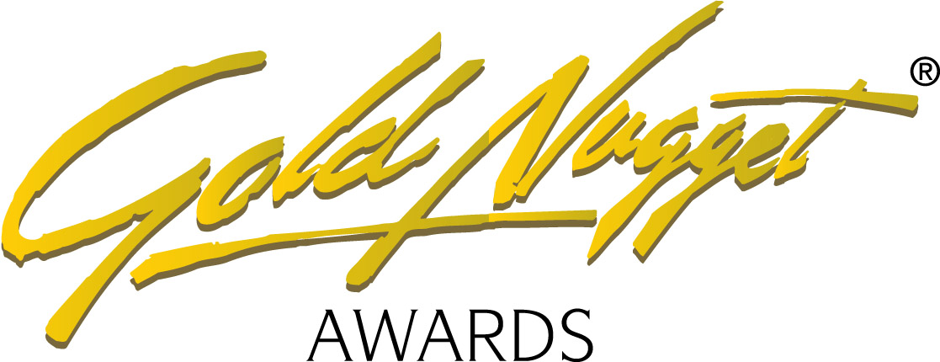

Gold Nugget Awards Co-Sponsorship Works!
Platinum, Gold, Silver, Bronze, or Friend Ceremony co-sponsorship is an ideal way to make your company’s name and product visible to your target market — the most successful members of the industry.
Select the sponsorship level that's right for your company

Platinum Ceremony Co-Sponsorship - $10,000
• Sponsors logos on the sponsor page with a link to your website.
• Company logo featured in the Gold Nugget Awards ads
• Your 60-second video promotion will appear during the Gold Nugget Awards Ceremony.
• Your color ad featured in the Gold Nugget Winners Book (online)
• Listing on the Co-sponsor Panel on the Gold Nugget Finalists displays.
• Your company representative to present a major Gold Nugget award during the awards ceremony.
• 6 images featured during the ceremony sponsor module. 3 company logos and 3 product images
• One complimentary VIP-reserved table of 10.
• Listing in Ceremony program

Gold Ceremony Co-Sponsorship - $5,000
• 6 images featured during the ceremony sponsor module. 3 company logos and 3 product images
• Listing on Co-sponsor Panel on the Gold Nugget Finalists displays.
• Your 30-second video promotion will appear during the Gold Nugget Awards Ceremony.
• One complimentary VIP-reserved table of 10.
• Listing in Ceremony program

Silver Ceremony Co-Sponsorship - $2,500
• 4 images featured during the ceremony sponsor module. 2 company logo and 2 product images
• Listing on Co-sponsor Panel on the Gold Nugget Finalists displays.
• 6 complimentary VIP-reserved ceremony tickets
• Listing in Ceremony program

Bronze Ceremony Co-Sponsorship - $1,500
• 2 images featured during the ceremony sponsor module. 1 company logo and 1 product image
• Listing on Co-sponsor Panel on the Gold Nugget Finalists displays.
• 2 complimentary VIP-reserved ceremony tickets
• Listing in Ceremony program

Friend Ceremony Co-Sponsorship - $750
• 1 Company logo image featured during the ceremony sponsor module.
• Listing on Co-sponsor Panel on the Gold Nugget Finalists displays.
• Preferred seating
• Listing in Ceremony program

Please see next page for payment instructions

Sponsorship Level
Amount
COMPANY NAME:
CONTACT NAME:
ADDRESS:
PHONE:
EMAIL ADDRESS:
Payment Preference: • American Express • Visa • Mastercard •
Credit Card Number
Expiration Date
Security Code
Name on Credit Card

MAKE CHECKS PAYABLE TO: Gold Nugget Awards

Return to:
Lisa Parrish | Administrator
Gold Nugget Awards - 10416 Hamilton St. Alta Loma CA 91701
909|987|2758 800|658|2758 909|987|1335 fax
lisa@teampmp.com

