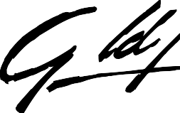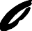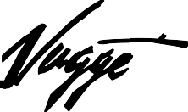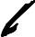

Duplicate Award Form

YEAR OF WIN: 2022 Gold Nugget

Please use separate order form for each type of merchandise ordered. If separate engraving instructions are required please use a separate form for each.

This order is for: AMOUNT ENCLOSED
Merit Award @ $175 each $
Gold Nugget Trophy @ $325 each $
Photo Plaque @ $275 each $
Home of the Year Trophy @ $375 each $

All items include postage and handling
Sales Tax @ 7.75% (California orders only) $

TOTAL $

ENGRAVING INSTRUCTIONS:
Please fill out completely when ordering. You must complete exactly as you wish engraving to appear.

Company Name Project name and Location Category Title

Ship to:

Name Company Address City/St./Zip Telephone Date

Please keep a copy of this form for your records. For delivery allow 6-8 weeks.
Questions? Contact: Lisa Parrish, Gold Nugget Awards (800) 658-2751 or (909) 987-2758

Send credit card information or check payable to GOLD NUGGET AWARDS, along with this form to: GOLD NUGGET AWARDS, 10416 HAMILTON ST, ALTA LOMA, CA 91701
EMAIL: Lisa@TeamPMP.com

Visa/MasterCard/Amex No. Expiration Signature Security Code
Charges will appear on your credit card as Gold Nugget Awards - Peter M. Mayer Productions

OFFICE USE ONLY: DATE: SERIAL # COPY SENT DATE SHIPPED

